Daily Huddle ED
Week of 6/20/21-6/26/21
COVID-19 Updates/Reminders:
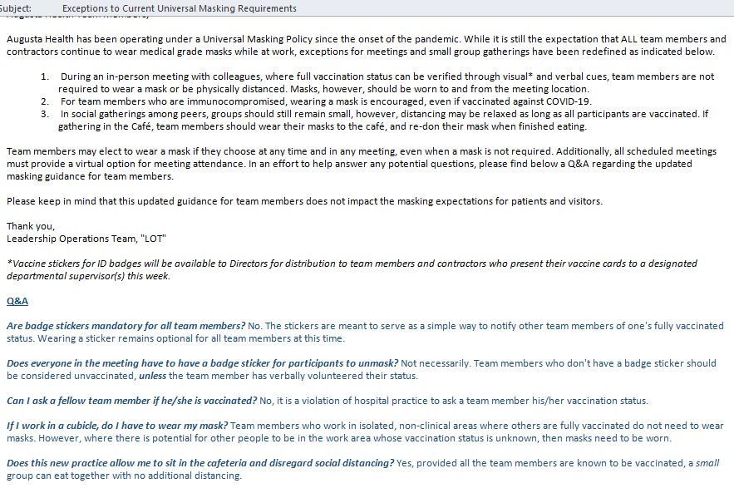

And Normal Business:
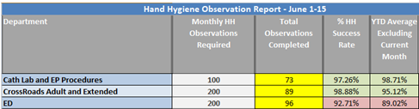

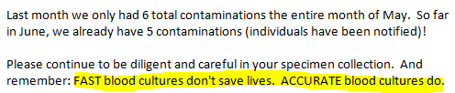

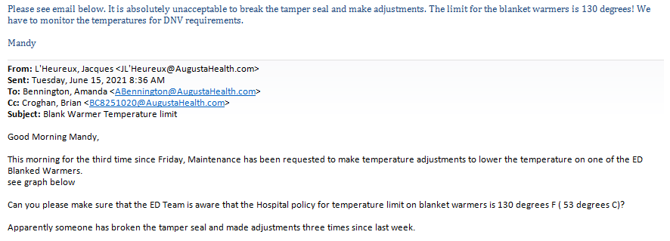

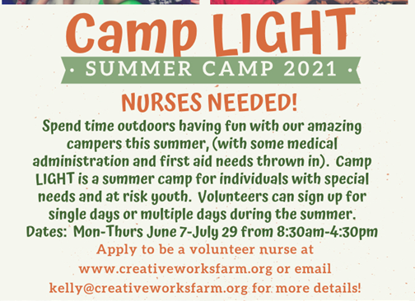

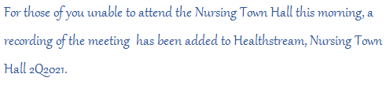
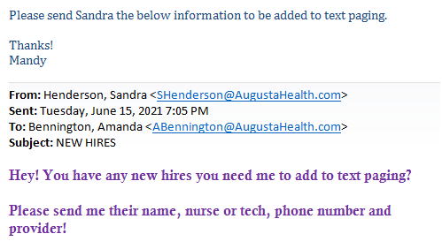
EDUCATION:
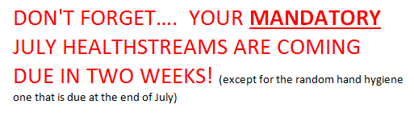

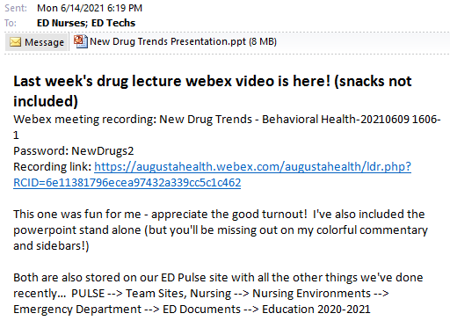

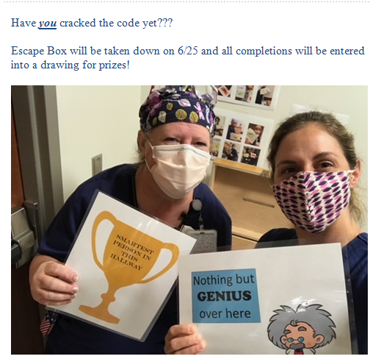

Kudos:
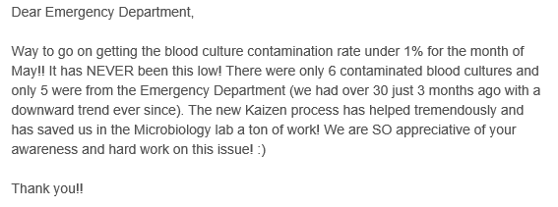
“Shout Out to Heather S. and Sarah F. on giving the new Antivenom med!”

“Great job to Amanda and Kaitlin in triage on being aggressive and getting pts back promptly.”

“Great job to EMTS for taking advantage of time to stock the department thoroughly.”

“Joe went to ICU and Medical to start 2 ultrasound IVs at 1830.”

“Heather (Shields) is an excellent nurse. She’s very pleasant and also humorous. My stay here has been excellent because of her!”

“Chris (Daugherty) is an incredible nurse. He’s very attentive and has kept me updated today. I’m extremely grateful for his care.”

“Special thanks to Chris C., Vera, and Candace for helping cover some holes.”

“Not exactly sure how the shout outs work, but wanted to say thanks to Stacey and Samantha for coming in a little early when asked on this busy day! They really helped us get through a difficult time. Everyone worked so hard today even though we were super busy!!”

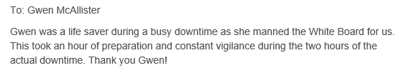
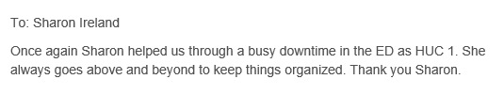
“Emily (Suttles) has been very sweet and attentive since I’ve been here today. I’m really thankful that Augusta Health has such excellent care!”

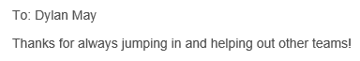
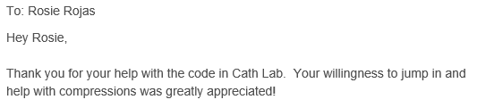
“Susan gave a shout out and sent a Shining Star to Donna Uhrig, a nurse in the ED who took excellent care of Susan’s Mom.”

Feedback:
“I am very impressed with Augusta. I normally would have been at RMH but was seeing an oncologist at time of ER visit (he sent me). Much more caring & organized than RMH.” – scored us a 10

“Excellent care, professional and even more important very very caring staff. I am a RRT @ UVA Transitional Care Hospital. Great great team.” – scored us a 10

“Staff tried hard to alleviate my urgent situation.” – scored us an 8

