Daily Huddle ED
Week of 7/11/21-7/17/21
COVID-19 Updates/Reminders:

And Normal Business:
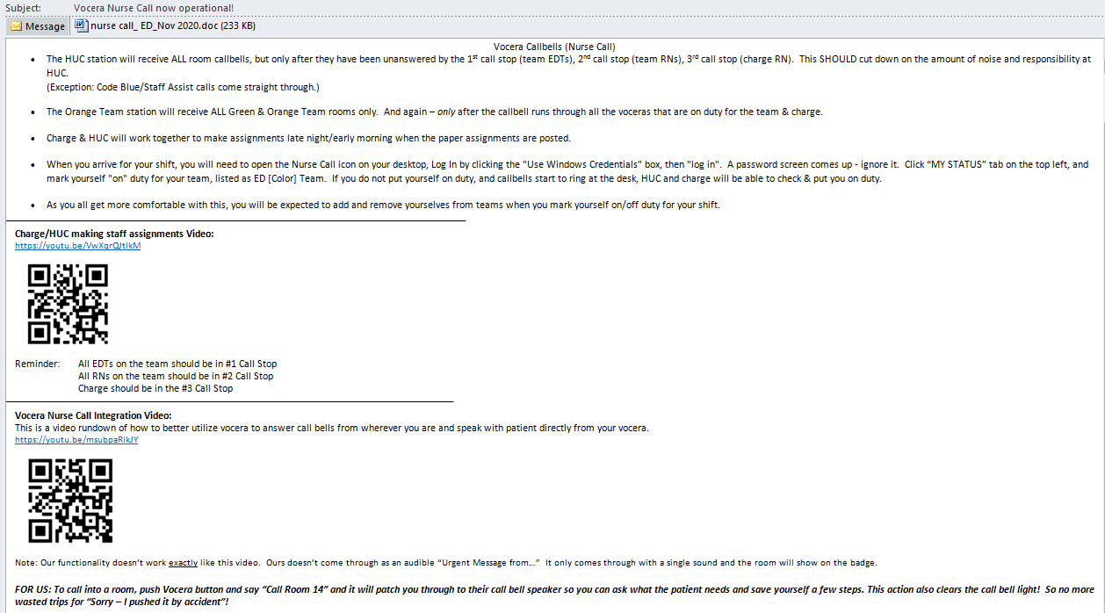

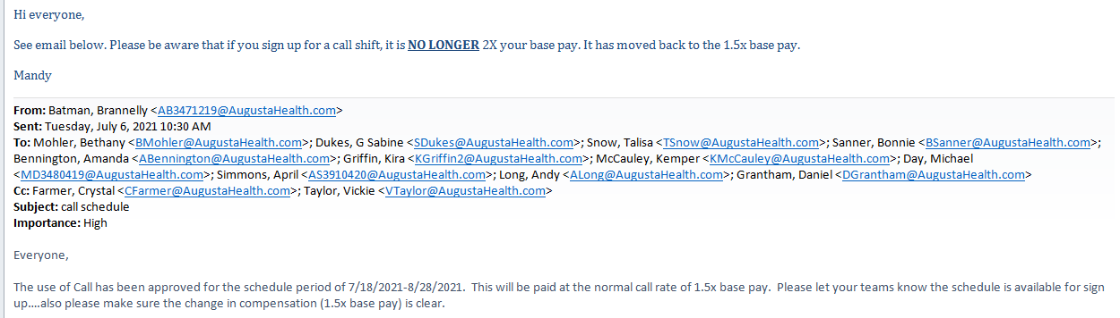

-All IV pumps should now read “Augusta 2021.Jul.6” at the top of the screen. If you are using a pump that does not state this, please power it off and then back on so that it can receive the most recent update.

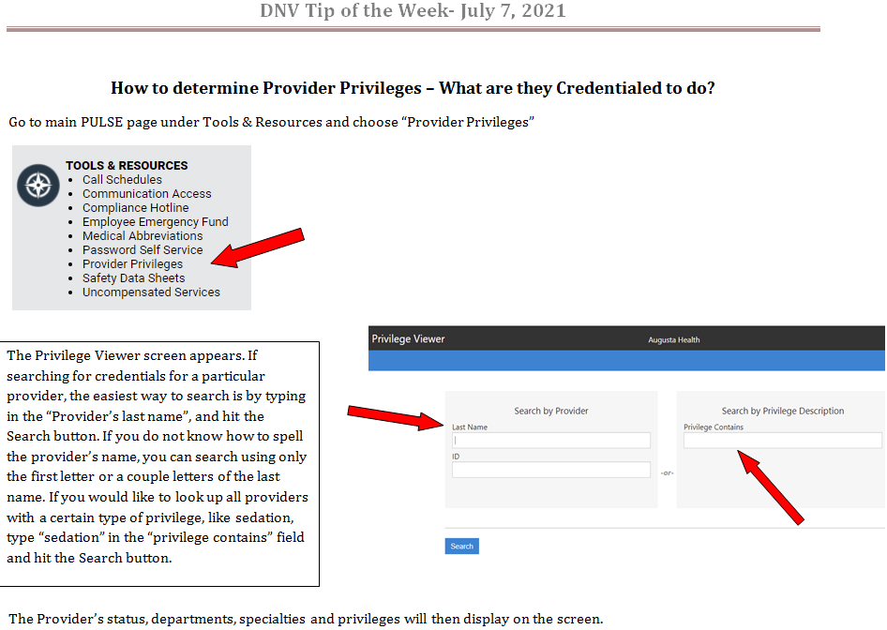

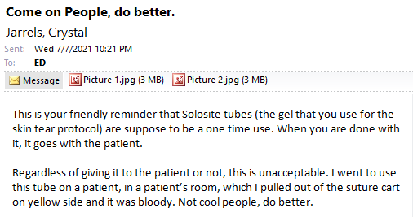
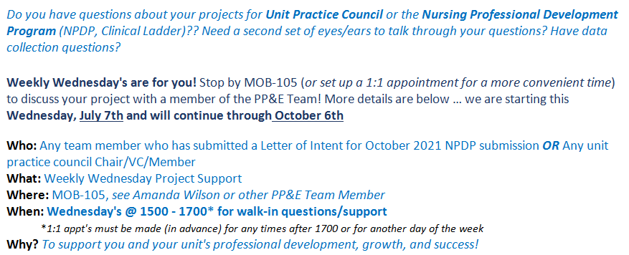

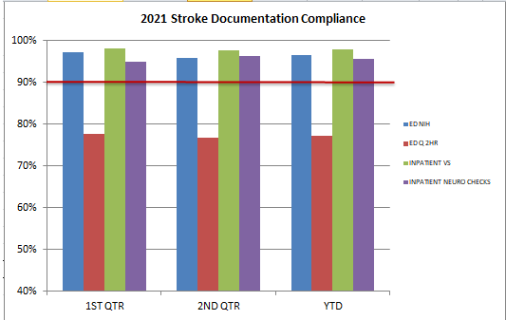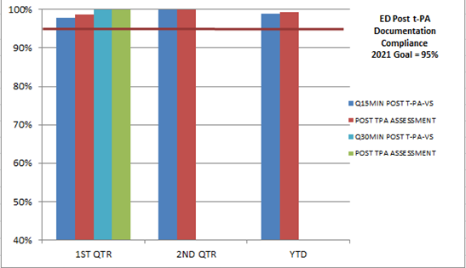

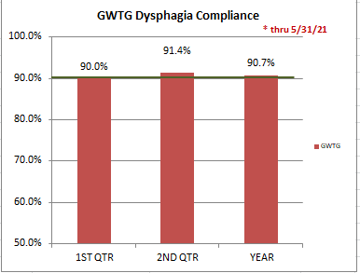

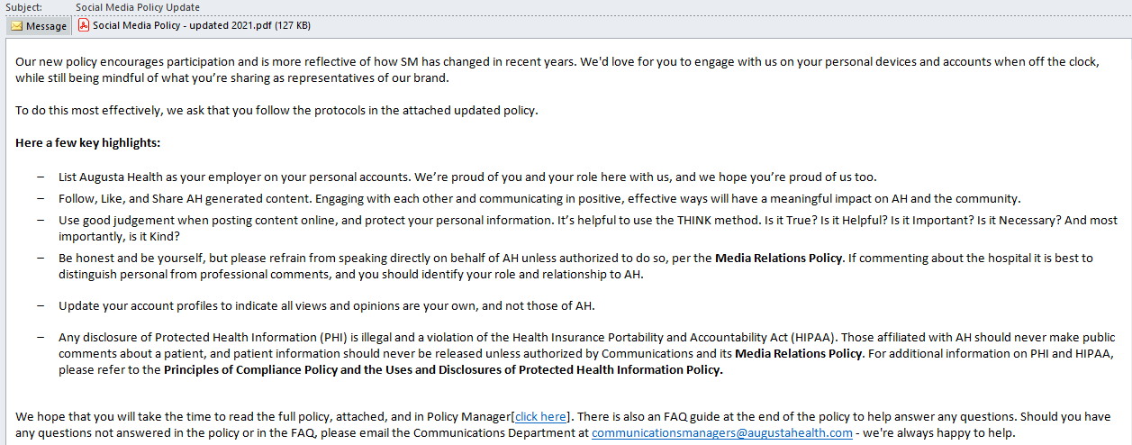

EDUCATION:
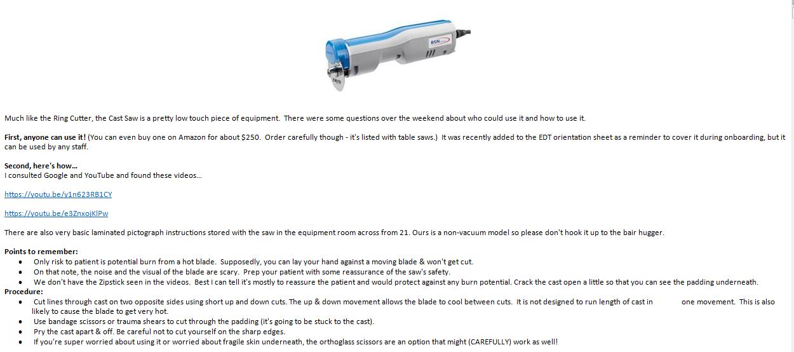
Kudos:
“Thanks so much to Donna, Alex, and Bre for staying over on a busy shift; they truly helped their team by doing this!”

-Congratulations to Scott for PERFECT post t-PA documentation!!!

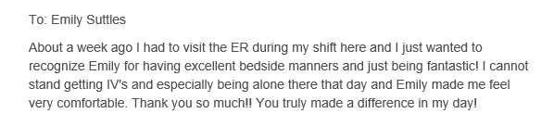
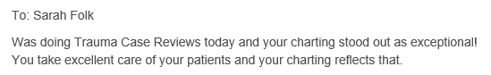
“Kaitlin working triage placed 2 pts on green & picked them up without being asked. Shes such an awesome team player!”

“Andrea was very organized at ensuring everyone had even time sitting/ q15 min checks. She also made sure everyone had lunch today!! Wonderful job as always”

