MRKR

Matthew Russell
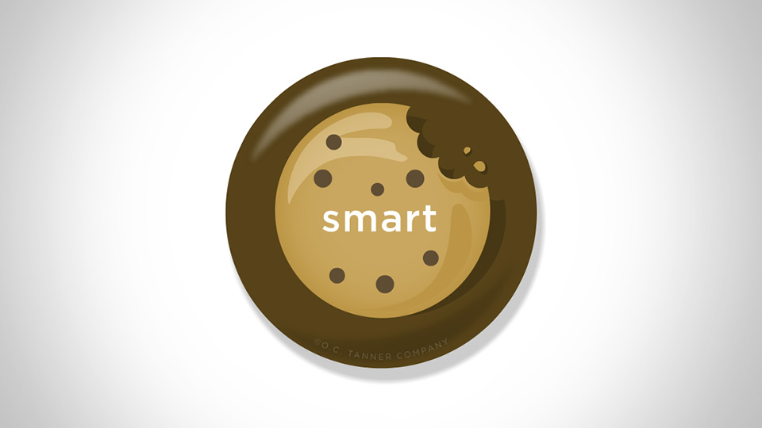
eCard: Smart Cookie
Kate Ramseywrites
Matt - thank you for sharing your wealth of knowledge with us and being a great resource!
View More

- CARDIAC CATH7 days ago
AHMR
View More

- CARDIAC CATH13 days ago
MRWG

Matthew Russell
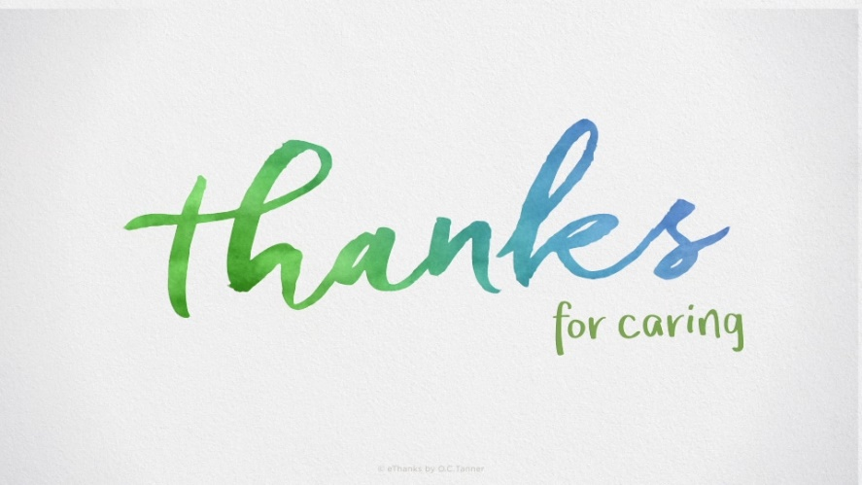
eCard: Watercolor Caring
Wendy Gibsonwrites
I just want to commend you on how you provided excellent care to a patient today. Your bedside manner, combined with your knowledge and experience provided an environment of care that made the patient feel at ease. You rock!
View More

- CARDIAC CATH15 days ago
MRAH

Matthew Russell
eCard: Encouragement On A Roll
Allison Hendersonwrites
Thanks for always being such a good mentor in the cath lab and always being so willing to continue to teach and educate our employees. I know I appreciate the continuing education!
View More

- CARDIAC CATH19 days ago
MRAH

Matthew Russell
eCard: Encouragement On A Roll
Allison Hendersonwrites
you did awesome helping us with that sick patient this morning. great team work buddy. appreciate all your help and hard work!
View More

- CARDIAC CATH26 days ago
MRBR

Matthew Russell
eCard: Encouragement On A Roll
Bobbi Rosenbergerwrites
Congratulations on passing the Cath Lab's first i-STAT Survey!! You are awesome!!
View More

- CARDIAC CATH1 months ago
MRES

Matthew Russell
eCard: Above and Beyond
Eric Stajduharwrites
Both of yall have really gone above and beyond lately taking such great care of our patients and furthering our department. Just wanted to say thank you!
View More

- CARDIAC CATH1 months ago
MRTS

Matthew Russell
eCard: Above and Beyond
Talisa Snowwrites
One of our ICU nurses was trying desperately to stay afloat while managing two patients that required a lot of work. Matt was coming to take a patient to the cath lab, but the patient also needed to have a CT completed. He helped out tremendously by taking the patient to CT for our ICU nurse. She was very appreciative and it helped so much! Thanks, Matt!
View More

- CARDIAC CATH3 months ago
MRLS

Matthew Russell
eCard: Above and Beyond
Lindsey Scott writes
Thank you for coming down to the ED and helping us when we were in surge. Just having a few extra hands to get some relief to the ED team was really helpful. We so appreciated your help yesterday!
View More

- CARDIAC CATH8 months ago
MRAW

Matthew Russell
eCard: We Beat as One
Amanda Wilsonwrites
Special THANK YOU for providing support for the annual Nursing Division Skills Fair 2021!! It takes a village and the PP&E team appreciates your engagement and willingness to help check off the nursing team this year - especially with many of you picking up multiple shifts! We could not have done it without you!

