Topic: Event Reporting
AH Procedures: Compliments of Beth. Chadwell, Director of Risk Management and Accreditation &
ONS Congress Presentation: Establish a Culture of Safety in Oncology Nursing Practice

Why I Chose Event Reporting as My Education Topic:
After attending the presentation, “Establish a Culture of Safety in Oncology Nursing Practice,” I felt passionate about ensuring that we (nurses and HCPs) feel encouraged to continue reporting events and near misses for the safety of our patients and ourselves, despite recent media attention on the topic. My mentality is: how can we fix a problem if we are unaware it exists? At the end of the presentation, attendees were encouraged to come up to the mic with questions and one attendee asked how organizations can help their staff feel safe reporting event now. The speaker replied: reporting nurses should be treated like the heroes they are!
Recently, Crystal Farmer spoke to SGC about our concern over retaliation related to event reporting after the RaDonda Vaught trial and how AH could decrease our concerns around these fears. Our input was open communication… Stay tuned for Listening Tours in the coming weeks; where staff can express concerns and share ideas around patient safety.

Key Takeaways from the Presentation:
- Most medical errors result from flawed systems, not reckless practitioners
- Systems learn from errors and improve, but only when those systems encourage
reporting, transparently acknowledge their mistakes, and are held accountable for those
errors
- Patient safety improves in organizations with fair and just cultures that value
transparency, openness, honesty, learning, and accountability at the system and
individual level.
- Criminalizing medical error creates environments and cultures of fear and blame that are counterproductive to patient safety
- Patient’s Role in Safety: help them be their own advocate!
  - Inform patients about the plan of care; patient education; include them in double-checks; encourage patients to pay attention &. Question unexpected changes

What is Event Reporting?
- Identification, reporting, investigation, and management of reportable events at Augusta Health. Helps us to identify patterns and trends in systems and processes to prevent harm to future patients and prevent organizational loss.
- Event reporting allows us to collect and analyze data related to actual and/or near miss events that occur to continually identify opportunities for improvement.

Why Report Events?
- PATIENT AND STAFF SAFETY
- Prompt investigation for evaluation
- Data use for Performance Improvement Activities
- Regulatory Requirements
- Change patient outcomes

Who is Responsible for Reporting?
- Personnel who are knowledgeable of the event and /or the person who witnesses, commits, or discovers the event. This information can also be reported by the department manager.
- If you wish to report anonymously, you may do so in writing to Augusta Health Director of Risk Management (Beth Chadwell) or Administrative Director of Quality.

Examples:
- Patient/visitor falls, with or without injury
- Medication errors
- Physical impairments, both permanent and temporary, arising during hospitalization
- Deviation from established policies or procedures which involve patient care or organization loss
- AMAs, attempted suicides, patient/visitor inappropriate behavior
- Complaints from patients/visitors regarding care or services not immediately resolved, requiring investigation or further action for resolution
- Medical equipment failures or malfunctions
- Electrical failures; IT /Telecommunications failures
- Environmental safety issues such as broken furniture or hazardous spills
- Accidents involving Augusta Health vehicles or staff on duty in private vehicles.
- Unprofessional conduct or behavior by staff
- Patient registration errors, such as wrong patient, name, address
- Patient or visitor personal property loss or damage

What to Document:
- Just the facts!! Objective Facts; avoid subjective statements
- Do not imply reasons for errors in care
- Do not throw your co-workers “under the bus”
- Clear concise and accurate information is essential. Reporting should be completed within eight (8) hours or the same shift as when the event took place.

How to Create an Event Report:

- Go to MeditechQMPatient NotificationEnter/Edit Patient Notification
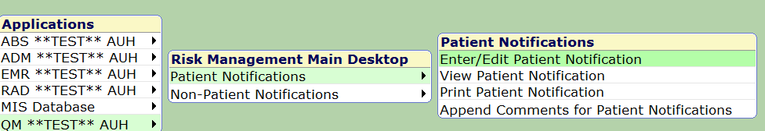

More Questions? Contact Risk Management at 245-7319

